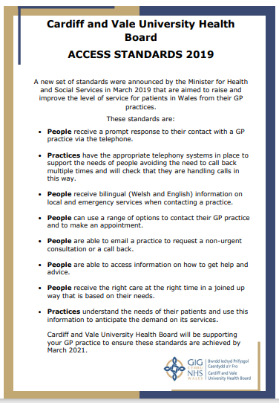
How to Make an Appointment
Pre-bookable and book on the day GP appointments are all available via reception desk, online via the NHS Wales App or by telephone.

Available same day GP appointments open online at 7.45am and 8.00am every working day, and by telephone at 8.00am every day, with an on-call GP available throughout the day for anything urgent arising during opening hours.

Advance appointments open at 9.00am every working day, for period ranging from 1 day up to 6 weeks ahead.

The surgery is contracted to close at 6.00pm and hands over to the GP Out of Hours service. To avoid handover to this service, please contact us as soon as possible during the working day.

You can email us to enquire about a non-urgent appointment at enquiries.w97053@wales.nhs.uk and a member of our team will email you back.

Cancellations
If you cannot keep or no longer require your appointment, please notify us as soon as possible. We have a strict DNA policy that can result in removal from the practice for repeat non-attenders.

Home Visits
If you are too unwell to attend the practice or housebound, please contact us by phone on 029 2061 2333 before 10.30. Home visits are assessed by the GP’s and are refused if deemed inappropriate.

Out of Hours – between 6.30pm and 8am ring 111

How does the NHS collect information about you?
Your doctor and the team of health professionals caring for you keep records about your health and any treatment or care you receive from the NHS. This information will either be written down (manual records) or held on computer (electronic records). These records are then used to guide and manage the care you receive.

For further information about how we use your information and sharing with other organisations, please visit our website.


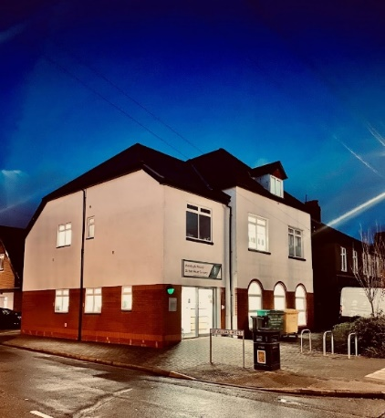

A patients guide to the practice at 46 St Isan Road, Heath, Cardiff, CF14 4UU

Dr Bethan Brooks MRCGP, DRCOG
Dr Matthew Jones MBBCh, MRCP, MRCGP
Dr Laura Ridgway MBBS, MRCP, MRCGP

Telephone: 029 2061 2333
Email: enquiries.w97053@wales.nhs.uk
Website: www.stisanroadsurgery.co.uk

The practice is a non-limited partnership

Dr Bethan Brooks (Senior Partner)
MB BCh MRCGP, DRCOG
Female
Part Time – Mon and Thurs

Dr Matthew Jones (Partner)
MB BCh, MRCP, MRCGP
Male
Full Time – Mon, Alt Tues, Thurs and Fri

Dr Laura Ridgway (Partner)
MBBS, MRCP, MRCGP
Female

Dr Bailey Davies (Salaried GP)
MB BCh, MRCGP
Female
Part Time – Alt Tues/Weds, Thurs and Fri

Dr Isaac Mayo (Salaried GP)
Male
Full Time – Tues, Weds, Thurs and Fri

Dr Thomas Purchase (Salaried GP)
Male
Part Time – Mon

Dr Sam Li (Salaried GP)
Male
Part Time – Fri

Dr Bronwen Price (Salaried GP)
Female
Part-Time Mon and Weds
Dr Manon Harry (Salaried GP)
Female
Part-Time Tues and Weds

Dr Maisie Richardson (GP Registrar)
Female
Part-Time
Mon, Tues and Fri

Nursing Staff
Nurse Loren Cottam
Nurse Suzanne Toogood
Nurse Suzanne Green
Ruth Leeds – HCA
Clinics
Ante-Natal | Asthma/COPD | Pre-diabetes
Minor Surgery | INR Clinic | Phleb – blood tests
Cytology | Well Baby | Learning Disability Checks
Contraception | Diabetic
Further information is on our website
Management
Practice Manager: Miss Claire Baker
Office Manager: Miss Charlotte Tarrant
Administration Manager: Mrs Sara Clark
We have an administrator/secretary and 5 reception staff
Surgery Hours
08.00 – 18.30 – phone lines
08.30 – 18.00 opening hours
Weekdays, excl bank holidays
How to Register as a Patient
Registration forms can be obtained from reception, or on our website where you can register online. Please provide your NHS number to speed up the process.

Repeat Prescriptions
These can be ordered via the NHS Wales App, email: prescriptionrequests.w97053@wales.nhs.uk, via the pharmacy or by dropping off your request in writing to the practice.

We DO NOT take prescription requests over the phone.

Medical Students
We are a teaching practice and accommodate students throughout the year. These include medical students, physician associates and pharmacy students. You will be asked to consent to seeing a clinician with students present, and you have the right to decline consent.

Suggestions or Concerns
Details of how to submit suggestions or concerns are available on our website, and we have a patient leaflet ‘Listening to People’ available hard copy at reception.

Please make any suggestions or relay any concerns in writing to the practice manager – claire.baker3@wales.nhs.uk or by phone 029 2051 9000

