EASY READ
PRACTICE LEAFLET
St Isan Road Surgery
029 20 612333

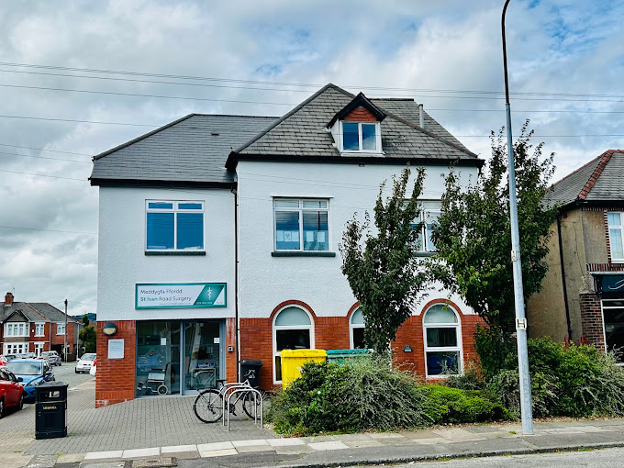

What this leaflet is about
This leaflet is about the services we offer at the doctors surgery

When we are open
We are open from 8.30 in the morning until 6.00 in the evening Monday to Friday

When we are closed
We are closed between 6.00 in the evening until 8.30 in the morning Monday to Friday
We are closed Saturday and Sunday
We are closed on bank holidays

How you can contact us – ring us from 8 in the morning
When we are open ring 029 2061 2333
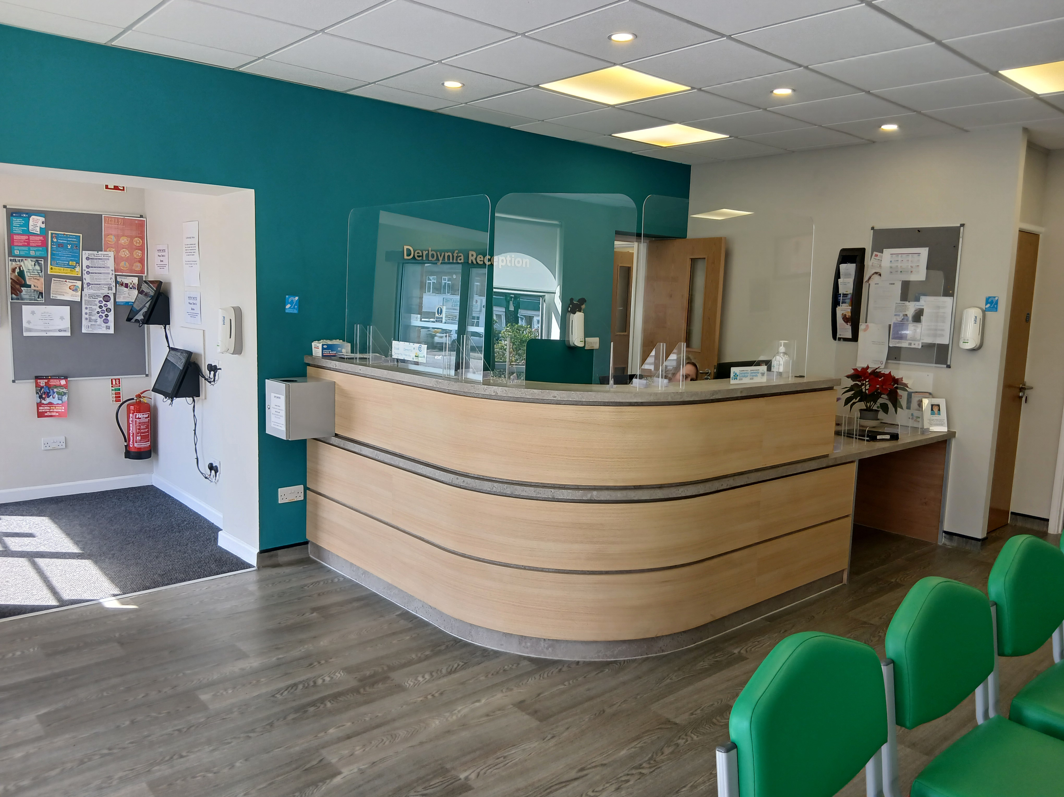
or email enquiries.w97053@wales.nhs.uk
or come to reception inside the building

When we are closed ring 111

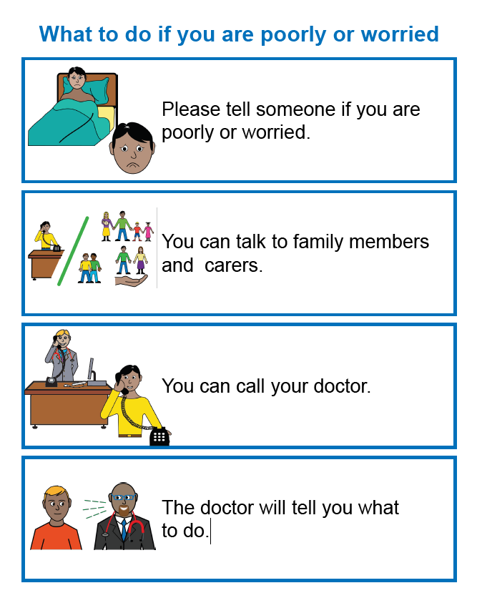

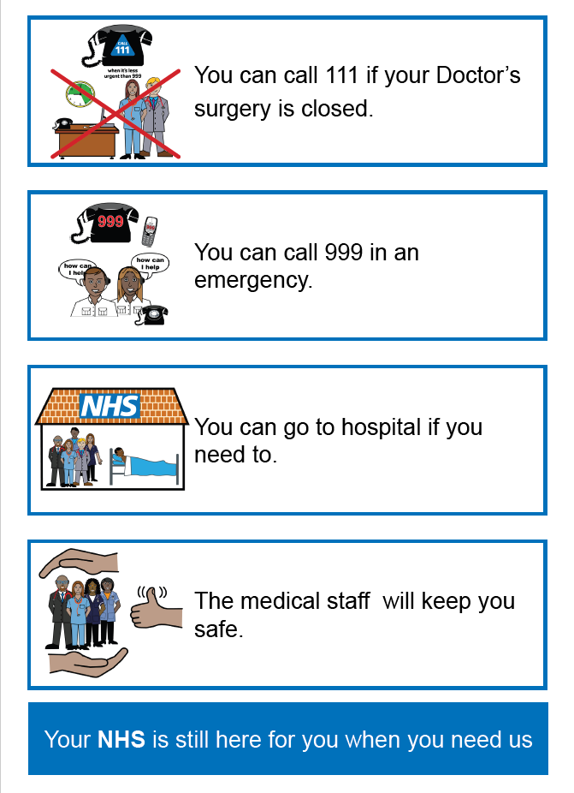

Disabled Facilities

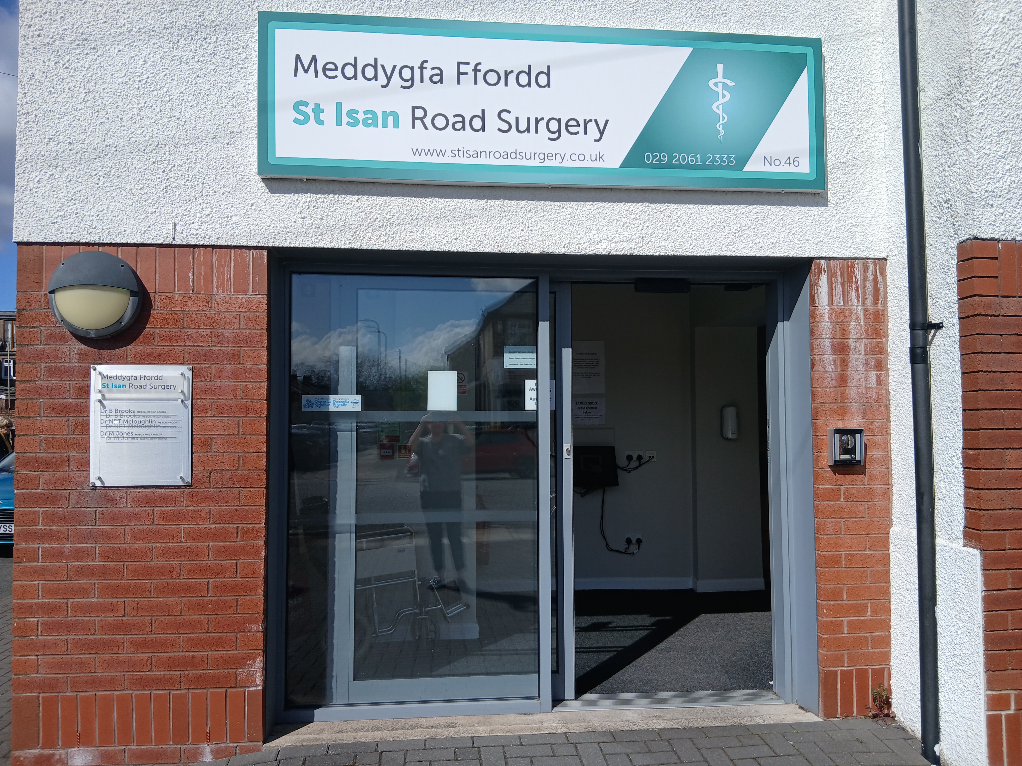

Automatic front doors

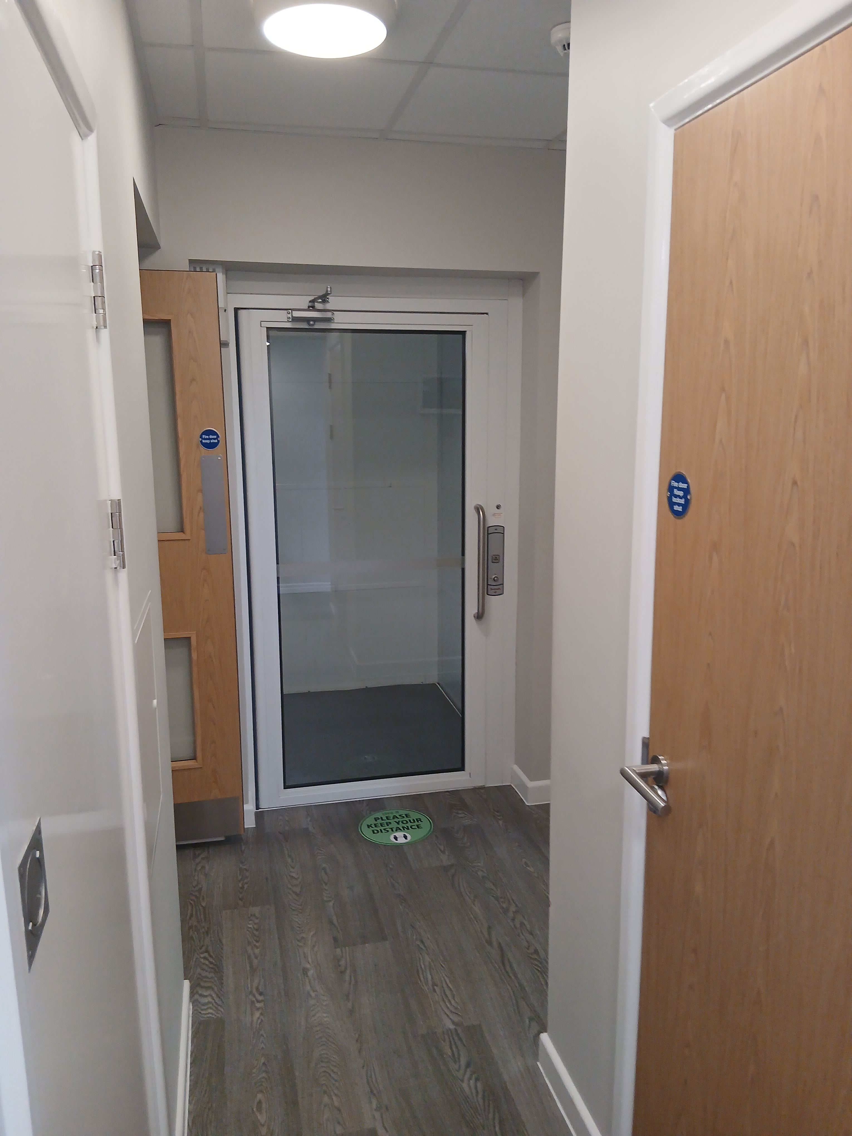

Lift

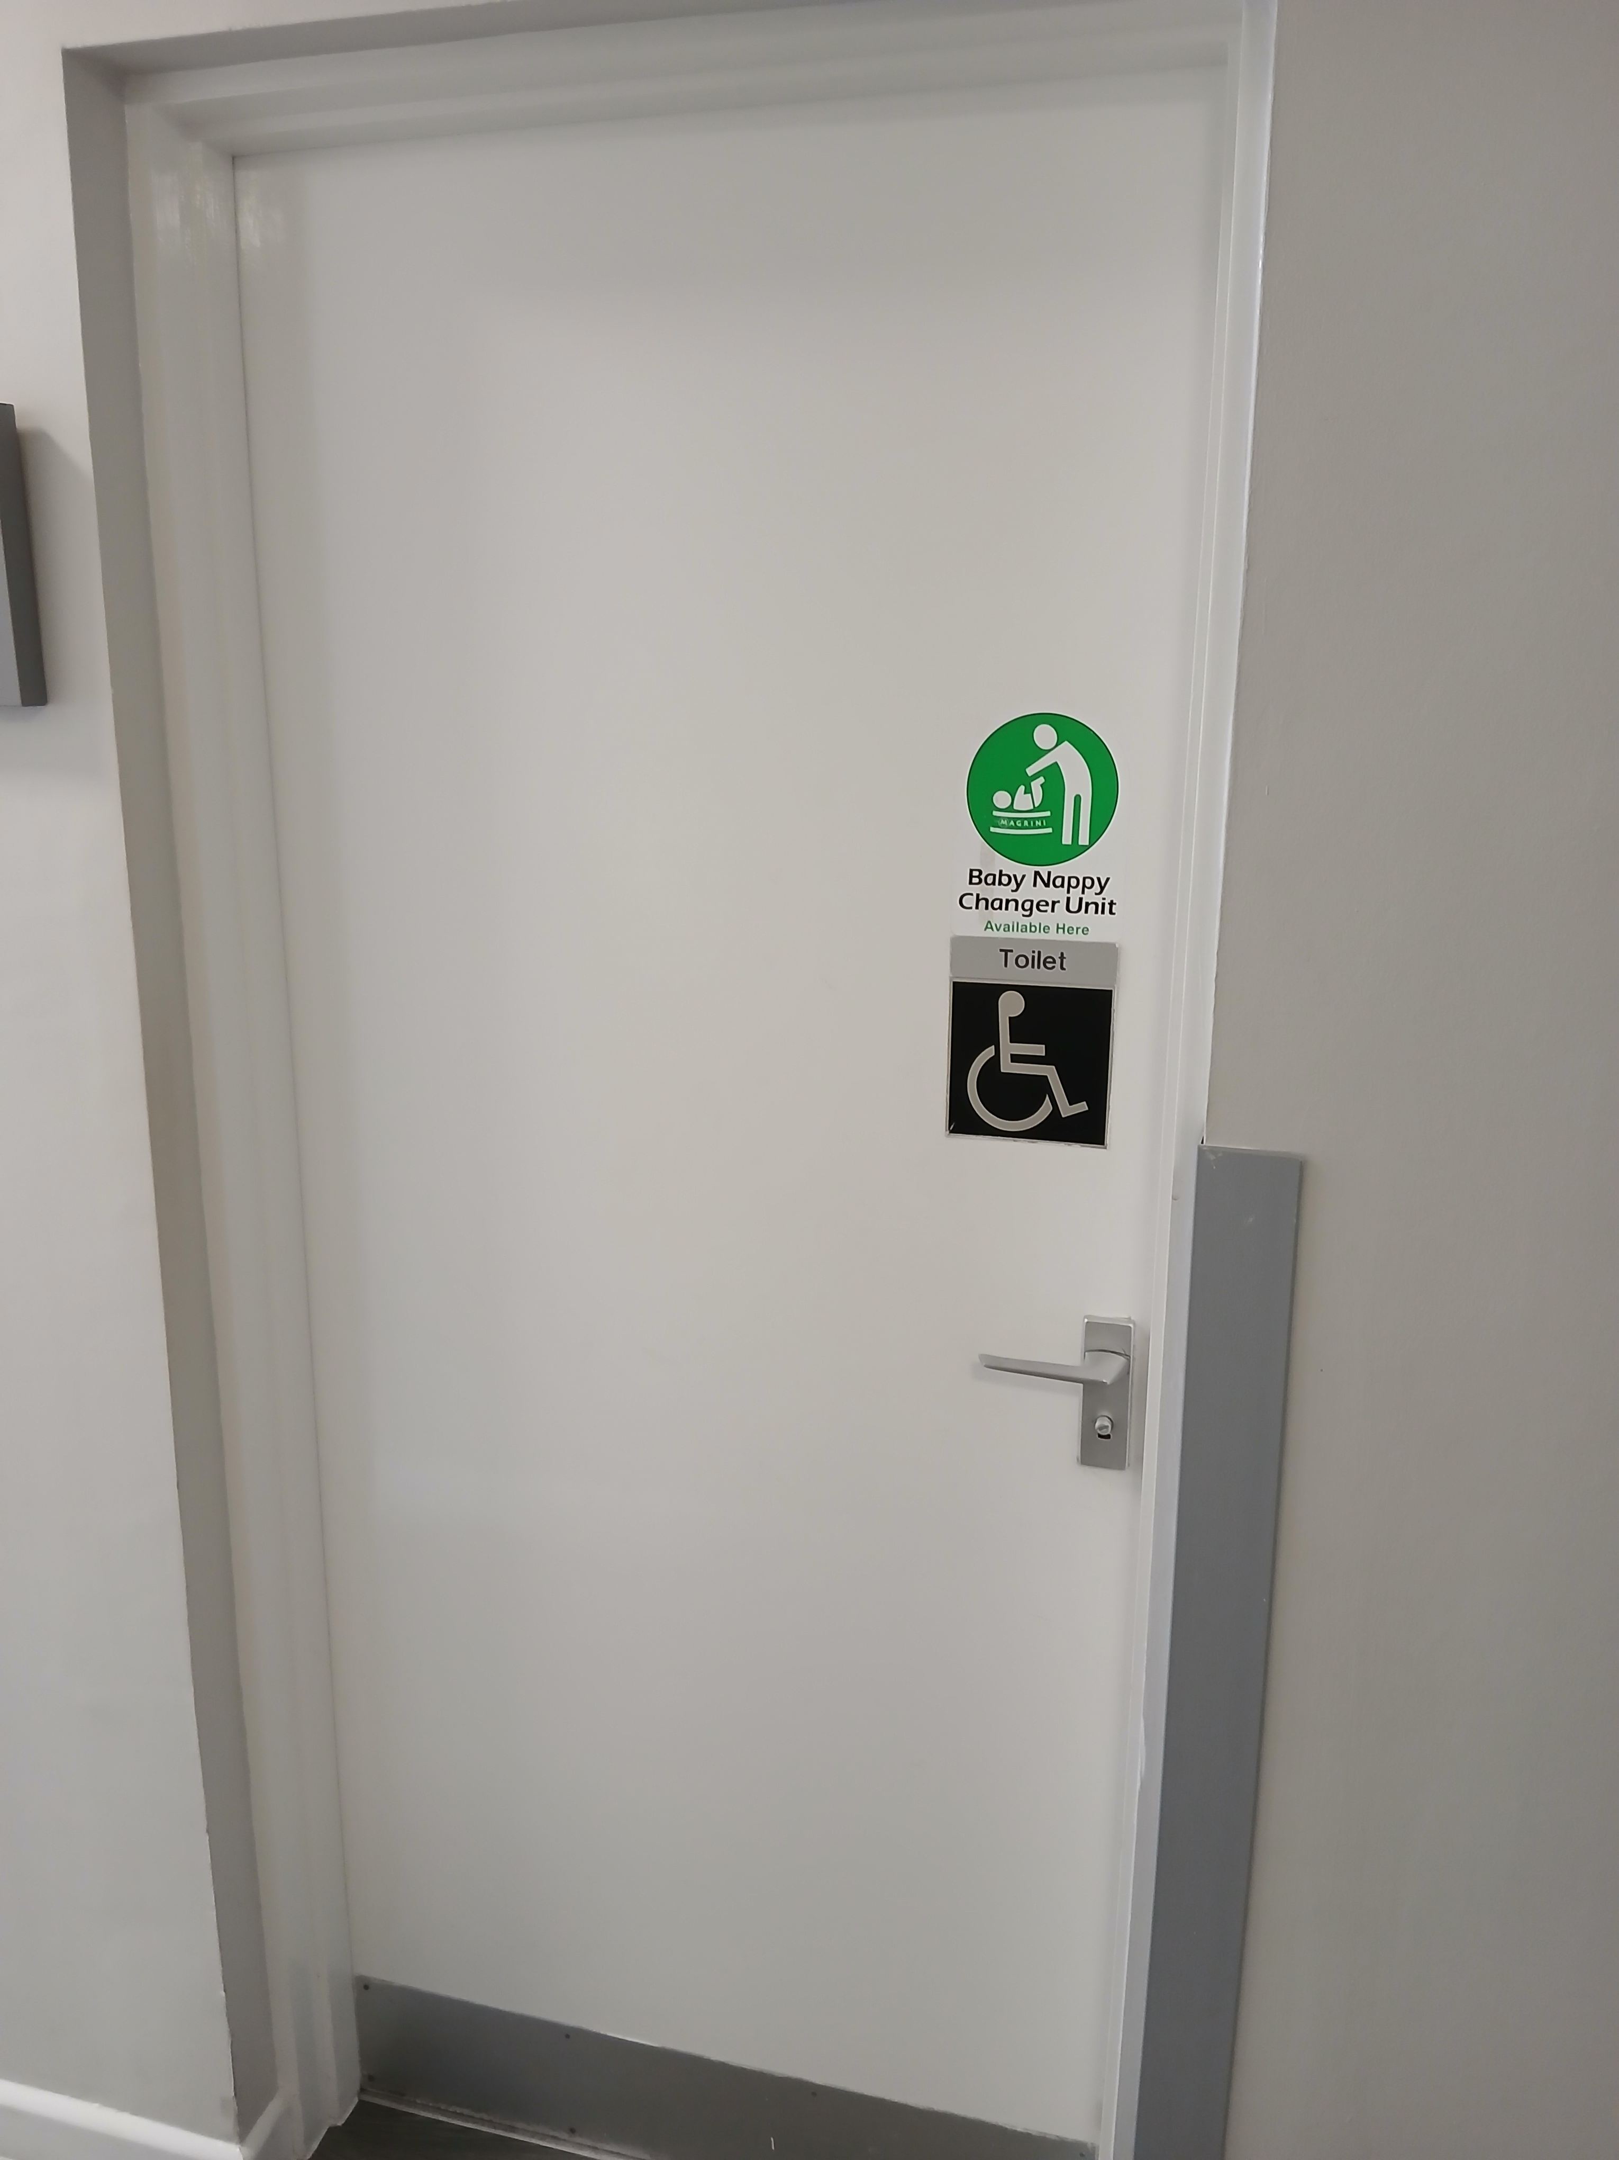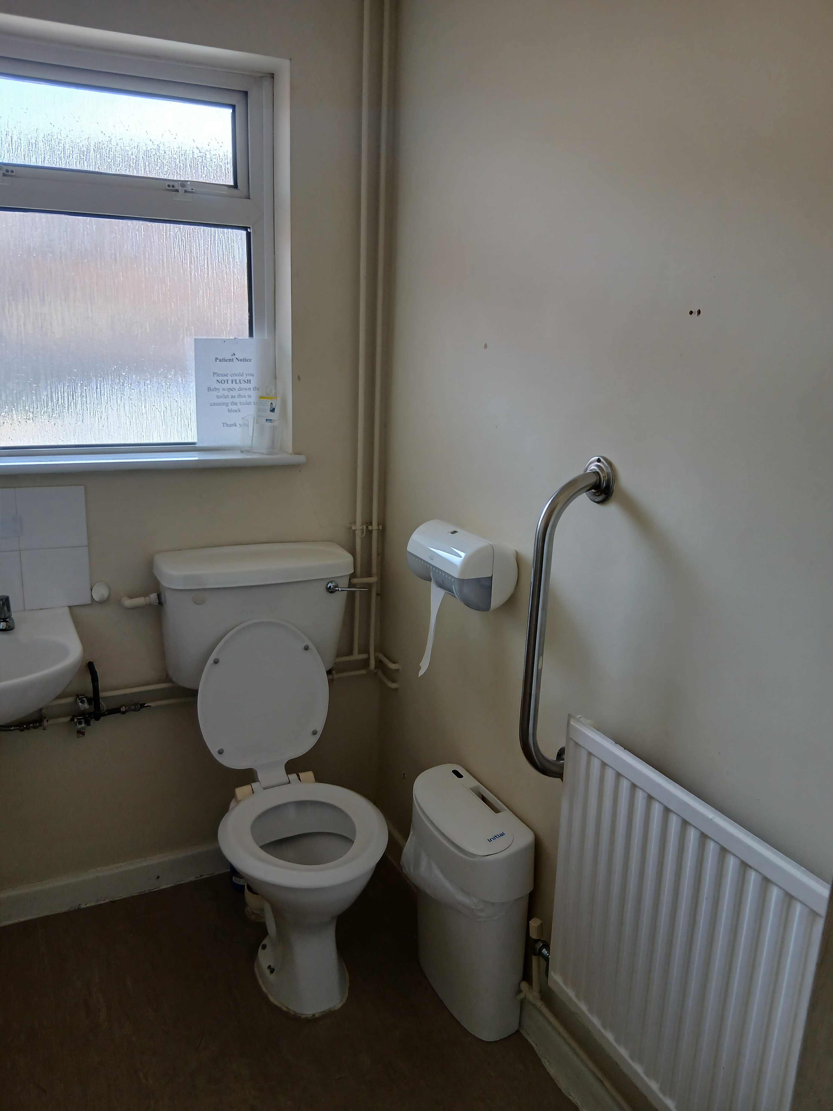

Disabled Toilet

Practice Staff
Doctors
Dr Sam Li
Dr Thomas Purchase
Dr Maisie Richardson
Dr Bronwen Price
Dr Manon Harry

Dr Bethan Brooks
Dr Noel Mcloughlin
Dr Matthew Jones
Dr Laura Ridgway
Dr Bailey Davies
Dr Isaac Mayo
Nurses
Nurse Suzanne Toogood
Nurse Loren Cottam
Nurse Suzanne Green
Ruth Leeds Health Care Assistant

Managers
Miss Claire Baker, Practice Manager
Miss Charlotte Tarrant, Office Manager
Mrs Sara Clark, Administration Manager
Administrators
Mrs Caron Yates
Receptionists
Ms Caroline Jones
Nicola Haslam-Jones
Kimberley Shepherd
Deborah Walker
Louise Hayes
Clinics
Asthma/COPD – practice nurse
Diabetes – practice nurse
Antenatal – midwife – clinics every Wednesday
Travel advice and vaccines – practice nurse
Cervical smears – practice nurse
Family planning – doctor
Hypertension – doctor
Over 75 Health Checks – health care assistant
Minor surgery/Joint Injections – ask at reception
Cryotherapy – ask at reception
Gender services – doctor
Flu Clinic – practice nurse – you will be invited
Prescriptions
Order through your local pharmacy or contact the practice and we will tell you what to do
029 2061 2333
Home Visits
If you’re not well enough to come to the surgery, ring us and ask for a doctor to come to your home.
029 2061 2333
If you are unhappy with us we want you tell us

Making a complaint means telling us about something you think is wrong or you are not happy with when visiting the doctor.

We want to look after you well and we want to sort out your problem or concern as quickly as possible. We can arrange for someone to talk to you straight away about what has made you unhappy.

If you do not want to talk to anyone you can make a formal complaint.

A formal complaint can be made to the Practice Manager, Miss Claire Baker

If you find it difficult to make a formal complaint on your own you can ask someone else to help you or do this for you. This can be one of your family or friends.
What happens if you make a formal complaint?
The practice will:
o tell you that your special complaint form has been received after 3 days.
o find out exactly what has happened within 10 days.
o If we need more time to find out what has happened we will tell you.
o We will see if you are happy to talk about your problem or complaint.
We will make sure that we say sorry if we have done something wrong.

To make a complaint please write to or ask to speak to:
Miss Claire Baker
Practice Manager
St Isan Road Surgery
46 St Isan Road
Heath
Cardiff
CF14 4UU
029 2051 9001
Claire.baker3@wales.nhs.uk
For more accessible information on our services and clinics, and what to expect when you visit us, please go to our website www.stisanroadsurgery.co.uk

