Making the Most of Your GP Appointment at St Isan Road Surgery


Visiting your GP can be a crucial step in managing your health,
but it's important to make the most of your appointment.
Here are some tips to help you prepare and ensure you get the
best care possible.


1. Do You Need an Appointment?
Before booking an appointment, consider whether you actually need one. We know it can be reassuring to speak to a GP about your concerns but as you know appointments are not an easy thing to come by. If we treat them as something of value and only use them when necessary, there will be more available when that need is really there for us, or our loved ones.
Here are some alternatives:

(click on headings for more info)
- Self Care: Many minor ailments can be managed at home with rest, hydration, and over-the-counter medications.

  - Choose Pharmacy Service: Pharmacists can provide advice and treatment for minor illnesses such as colds, coughs, and sore throats.


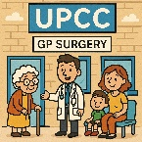
  - UPCC (Urgent Primary Care Centre): For acute illness. This centre is staffed by GPs who see acute illnesses in patients all across the North of Cardiff from any of the GP surgeries there. Our receptionists can direct the most appropriate patients to this centre allowing more complex cases to be seen by our clinical staff.
  - Optometrist for Eye Issues: For eye problems, an optometrist can often provide the necessary care, rather than a GP.
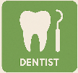
  - Dentist for Dental Issues: Dental problems should be addressed by a dentist, not a GP.

- Waiting times for specialists are sadly very high and we recognise how frustrating it is to get access to them for 1st and follow up appointments. However, rather than asking a GP to chase hospital tests or appointments, or check where you are on a waiting list, you can find information from the hospital by either ringing the department you attended or following this link: https://cavuhb.nhs.wales/hospitals-and-health-centres/our-hospitals/uhw/your-appointment/waiting-for-your-treatment/
This helps GPs offer valuable appointments to patients for issues that only we can help with.

Accident & Emergencies: As the name suggests the appropriate place for accidents and/or emergencies is not the GP surgery, it is A&E. There are good reasons for this. Emergency conditions such as suspected heart attack or stroke need rapid care and investigations that only the hospital can provide. Coming to see a GP first only wastes valuable time in your care as you will need to be sent to A&E anyway. Similarly, x-rays requested by a GP can take a couple of weeks to book and several more to get reported. If you think you may have broken a bone, you need to go to A&E. The GP has no ways of fast tracking you past any waiting times. You can however check local waiting times in local A&E and minor injury centres by following this link : My A&E Live - NHS Wales Accident and Emergency Departments

2. Do I Need a Face-to-Face Appointment?
Consider whether your issue requires a face-to-face appointment or if it can be handled over the phone:
- Face-to-Face: Necessary for issues that require a physical examination.
- Telephone Appointments: Can be quicker and more convenient for some patients, especially if you have other commitments. This type of appointment may not happen at the time that you call, and can occur anytime during the morning or afternoon. Therefore, having access to your phone is essential during this period. Patients can request calls to be around particular times but these cannot always be guaranteed.
- Unfortunately, we do not have an alternative system, at present. If the GP needs to see you in person, this will require a second appointment, which can be an inefficient use of telephone appointments, so please consider this before calling.
3. Be On Time
Arriving on time for your appointment ensures you get the full 15 minutes allocated. Being late can reduce the time available with the GP and may cause delays for other patients. Modern General Practice is complicated and very busy. Despite our best efforts many appointments sadly overrun as some unwell patients may require longer than the allocated 15 minutes. Please be patient with staff during these times and be prepared that sometimes you may have to wait. In the future it could be you or a loved one who requires this extra time.
Keeping to time is also important.

Appointments are typically 15 minutes long, which includes time for the GP to write up the consultation and make any necessary referrals or requests for investigations. This is usually enough time to deal with one problem. If you have multiple issues or need an interpreter, please request a double appointment. During your appointment try to be concise to help us keep to time.
4. Come Prepared
- Prioritise Your Issues: Focus on the most serious issues first. This allows the GP to address the main concerns without being distracted by multiple smaller issues.
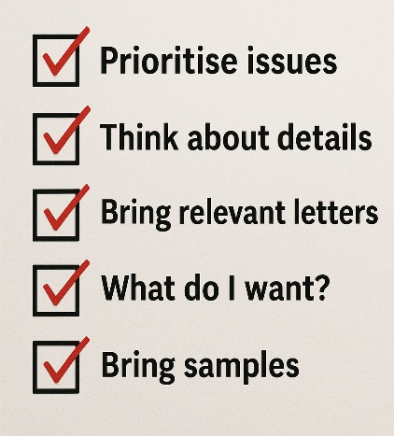
- Think About the Details: How long has the problem been occurring? Be specific about the duration (hours, days, weeks, months, years) and how it has changed over time. Saying “its been bad for ages” or “not long” is less helpful. Describe how it affects you at home, work, and during recreation.
- Bring Relevant Letters: If you have seen a specialist recently, bring any letters or documents they provided, as these can take time to reach the surgery and may not be with is by the time of your appointment.
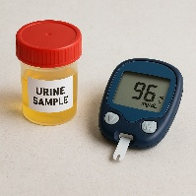
- Think about what you want out of the consultation: Providing healthcare is about managing what a patient needs not necessarily what they want. What you want may not be possible but if we understand what it is we can at least discuss and explain the limitations of NHS care and avoid unnecessary repeat appointments
- Bring samples/results: Think about what you are being seen about Will the GP want to check a urine sample? Review your home Sugar or BP readings. Bringing these along will help speed up your appointment.

5. Be Clear About What You Want and Are Willing to Do
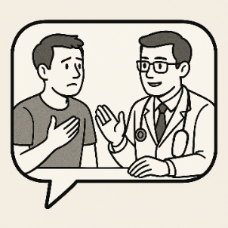
Your GP will recommend investigations or treatments they believe are best, but it's important to be honest about what you are willing to do. If you have concerns or specific expectations, communicate them clearly. This helps the GP tailor their advice and ensures you receive the most appropriate care. Sending you to see a specialist you don’t want to see or prescribing a medication you won’t take is a waste of time for you and for us.

6. Don't Be Embarrassed
Remember, your GP has seen and heard it all before. Don't let embarrassment prevent you from discussing your symptoms openly and honestly. You can of course request an appointment with a male/female GP, which we will do our best to accommodate.

7. Write Down Questions
Before your appointment, write down any questions you have. This ensures you don't forget to ask something important whilst with the GP. Be realistic -remember we only have 15 minutes so lists need to reflect that.

8. Bring a Friend or Family Member if needed
If you feel anxious or think you might forget what the GP says, consider bringing a friend or family member for support. They can help you remember the details discussed. If possible, try not to bring younger family members who can be a distraction in the appointment and make it more difficult to talk about sensitive issues

9. Understand the Next Steps
Before leaving your appointment, make sure you understand what will happen next. This includes any follow-up appointments, tests, or treatments. Write down or record on your phone any follow appointments or plans going forward you are worried you may forget. How are you going to get your results and what happens after that are important and reasonable questions to ask.


10. Don't over rely on Google
While it's good to be informed, avoid quoting information from the internet unless it's from a reputable source. Not everything on the internet is accurate or relevant to care in the NHS. Your GP can provide the most accurate and relevant advice for your situation.
11. Be Nice
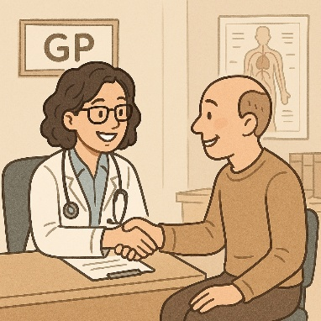
We understand that getting an appointment can be frustrating, but this is due to resource allocation in primary care, not the fault of the practice staff. Everyone at St Isan Road Surgery wants to help you. Being polite and clear about your needs will help us assist you more effectively. Remember, managing health on the NHS is about addressing patient needs, which may not always align with patient wants, but we strive to do our best.

By following these additional tips, you can ensure your GP appointment is as productive and effective as possible. For more information and resources, visit our website www.stisanroadsugery.co.uk
Help us to help you. Thank you.

